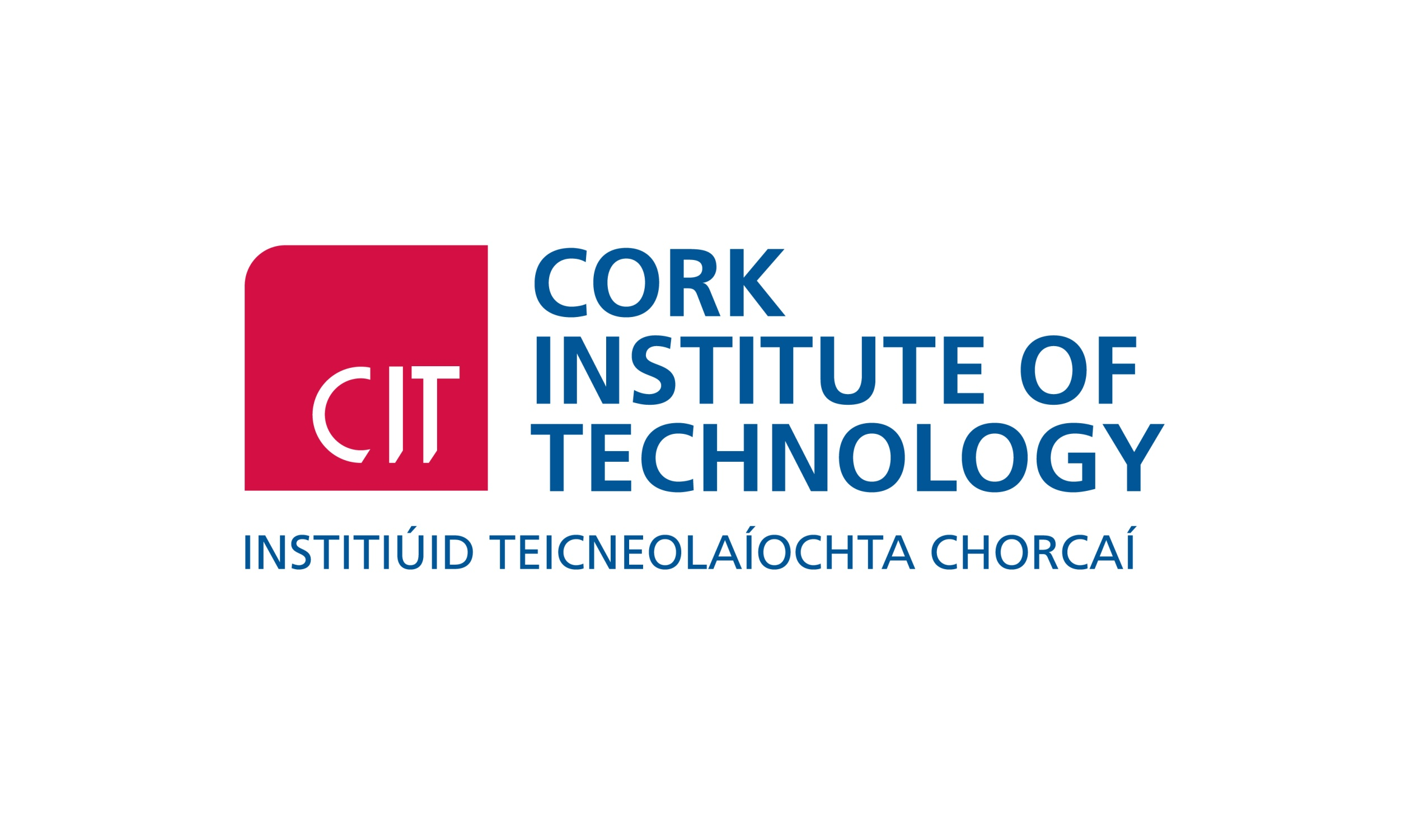

CORK INSTITUTE OF TECHNOLOGY
2015 POSTGRADUATE FAIR

Tuesday 24th February 2015
11.00 – 2.00pm
Nexus Student Centre, CIT
Bishopstown Campus

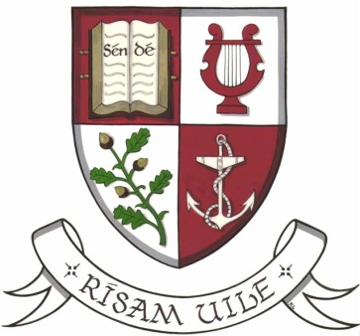
BOOKING FORM

University/Institution: ____________________ Department: __________________

Address: ____________________________________________________________

Contact Person: _____________________ Telephone: __________________

Email: _____________________

Are you bringing a stand? Yes No

If YES details of stand dimension: H (ft.) ___ W (ft.) ____

Do you require a table and chairs? Yes No

*Do you require electricity? Yes No

Do you require parking? Yes No

How many people will attend? ___ ______

*Please note that this venue does not provide access to power points for all stands so they will be allocated on a first come first serve basis. Also please note that the area has wireless internet access.

Please return by email//post to: Web: www.cit.ie/graduateschool

Andrea O’Driscoll,
School of Graduate Studies,
Cork Institute of Technology, Bishopstown, Cork

Tel: 021 4335099 Email: andrea.odriscoll@cit.ie

